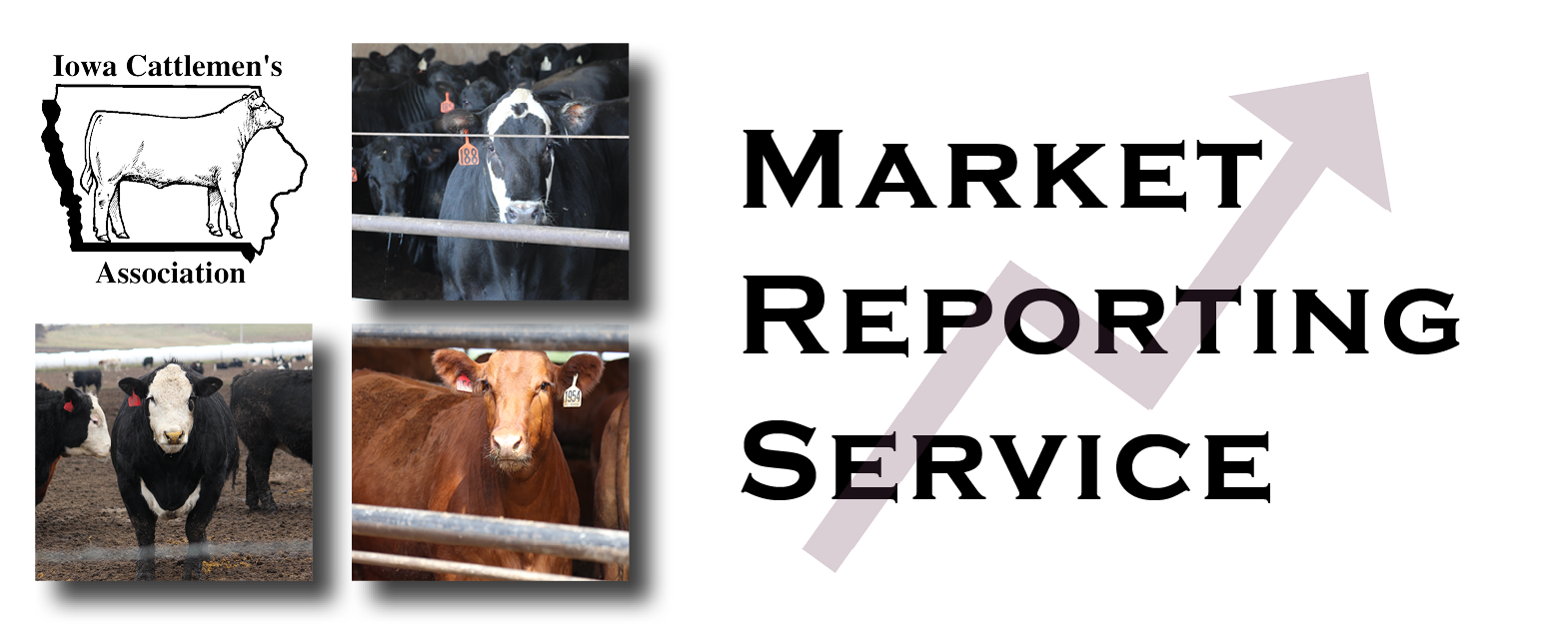

This program is one of the nation’s most respected sources for timely and accurate fed cattle market information and analysis to help you make informed marketing decisions. The MRS was established by the Nebraska Cattlemen in 1989 and in partnership, the Iowa Cattlemen’s Association has offered the service to our members for more than 10 years!
Try a 30-Day FREE Trial OR Sign-up Today!

MRS Base Package includes:
- Unlimited “800” telephone access for your personalized questions
- 9:35 a.m. conference call with two full time analysts
- Cost $350 minimum plus $0.35 per head of lot capacity annually

CURRENT lot capacity ____________ x $0.35 $
($350 minimum)
Annual Additional Media Package includes:
- All Basic Package Access PLUS
+
- MRS Website Access $ 360.00
- SMS text and/or email information delivery
- NEW App access downloaded to your phone
Total Enclosed $

It is VERY important that everyone calls in bids and sales. That is what makes the system work!

Please select an option:  Sign me up!  I’d like to try a 30-Day FREE Trial

How would you like MRS information sent:  Text  Email  Both

Name: _____________________________________________________________________________________
Address: ________________________________ City: _________________ State: ______ Zip: ____________
Home phone: _________________________ E-mail: _______________________________________________
Cell phone information is necessary so that we can structure SMS text messaging address correctly
Cell phone: ___________________________ Cell phone provider: ___________________________

Form of payment if signing up for this service:  Credit Card       Check #______________

MasterCard/Visa/Discover Card #: ---

Expiration date: / Name on card:
Signature: __________________________________________________

Make Payment to:
Iowa Cattlemen’s Association, 2055 Ironwood Court, Ames, IA 50014
Phone 515-296-2266 ۰ FAX 515-296-2261 ۰Email: iacattlemen@iacattlemen.org

